NAME: VENKATRAMAMOORTHY.G
- Use push, pop, shift, unshift on an array.
These are basic operations used to add or remove elements from an array.
- push() Adds element to the end
- pop() Removes last element
- unshift() Adds element to the beginning
- shift() Removes first element
CODE:
arr=[];
for(let i=1;i<=5;i++){
arr.push(i);
}
console.log(arr);
arr.pop();
console.log(arr);
arr.unshift(0);
console.log(arr);
arr.shift();
console.log(arr);
OUTPUT:
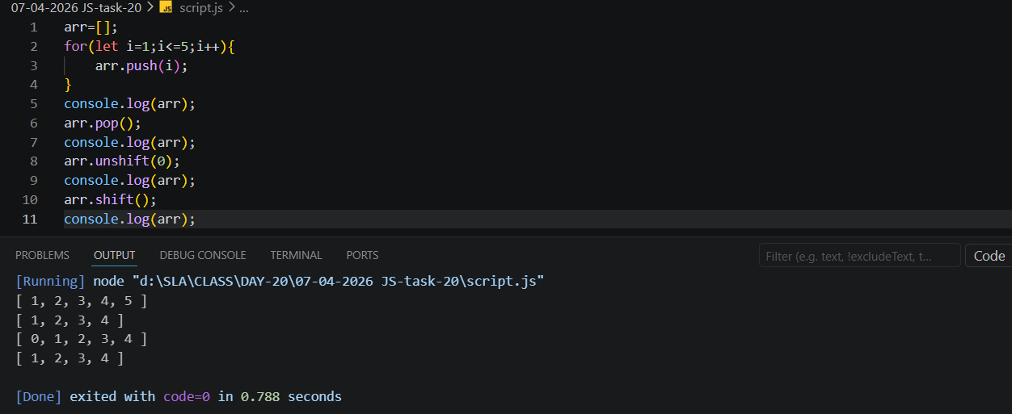
- Print all elements of an array using for loop.
CODE:
arr=[];
for(let i=1;i<=5;i++){
arr.push(i);
}
console.log(arr);
for(let i=0;i<arr.length;i++){
console.log(arr[i]);
}
OUTPUT:
